Project

**Generate Payment Reference ID : SAPI**

# Business Scenario

This API will generate a unique payment reference ID.

# API Landscape

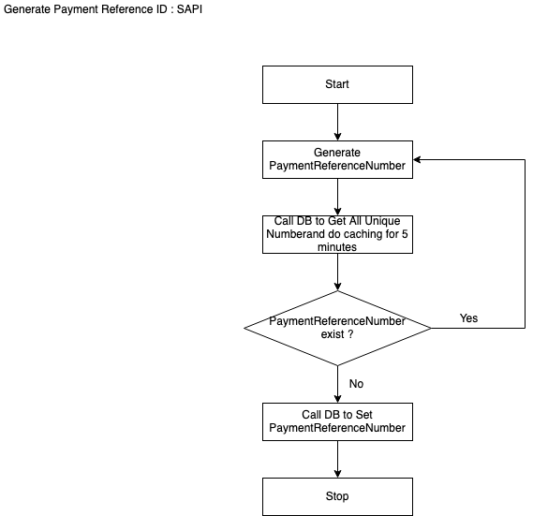

Sequence Diagram Web Application

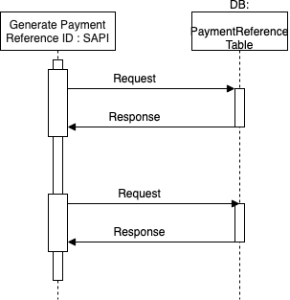

API Details:

|  |  |
| --- | --- |
| **Version** | 1.0.0 |
| **Resource** | payments |
| **Method** | GET |
| **Objective** | This API will generate a unique payment reference ID. |

INPUT

Header:

|  |  |  |  |
| --- | --- | --- | --- |
| **Field Name** | **Field Rule** | **Mandatory** | **Type** |
| x-abc-transactionId | Use for logging and tracking purposes. Example: hdsfhjdh-jxbv859-sjdf7643-3746bbd  MinLenght = 36  MaxLength = 36 | Y | String |

OUTPUT

200

Type: Application/json

Output message for generate payment referenceID

|  |  |  |  |
| --- | --- | --- | --- |
| **Field Name** | **Field Rule** | **Mandatory** | **Type** |
| paymentReferenceId | MinLenght = 30  MaxLength= 40 | Y | String |

Example :

{

"paymentReferenceId" : "jhsjhfdg38746736sdkj”

}

400:

Body: MIME-Type= application/json

Output message for generate payment referenceID

|  |  |  |  |
| --- | --- | --- | --- |
| **Field Name** | **Field Rule** | **Mandatory** | **Type** |
| errorCode |  | Y | Number |
| errorMessage |  | Y | String |

example:

{

"errorCode": 400,

"errorMessage": "BAD Request"

}

401:

Body: MIME-Type= application/json

Output message for generate payment referenceID

|  |  |  |  |
| --- | --- | --- | --- |
| **Field Name** | **Field Rule** | **Mandatory** | **Type** |
| errorCode |  | Y | Number |
| errorMessage |  | Y | String |

example:

{

"errorCode": 401,

"errorMessage": "UnAuthorised"

}

404:

Body: MIME-Type= application/json

Output message for generate payment referenceID

|  |  |  |  |
| --- | --- | --- | --- |
| **Field Name** | **Field Rule** | **Mandatory** | **Type** |
| errorCode |  | Y | Number |
| errorMessage |  | Y | String |

{

"errorCode": 404,

"errorMessage": "Not Found"

}

500:

Body: MIME-Type= application/json

Output message for generate payment referenceID

|  |  |  |  |
| --- | --- | --- | --- |
| **Field Name** | **Field Rule** | **Mandatory** | **Type** |
| errorCode |  | Y | Number |
| errorMessage |  | Y | String |

{

"errorCode": 500,

"errorMessage": "Critical Error"

}